**Hands-On: Stage 4 - Web API – Tools, Attributes - Day 74 – Hand sons**

1. **Web Api using .Net core with Swagger**

**Startup.cs**

using Microsoft.AspNetCore.Builder;

using Microsoft.AspNetCore.Hosting;

using Microsoft.AspNetCore.HttpsPolicy;

using Microsoft.AspNetCore.Mvc;

using Microsoft.Extensions.Configuration;

using Microsoft.Extensions.DependencyInjection;

using Microsoft.Extensions.Hosting;

using Microsoft.Extensions.Logging;

using Microsoft.OpenApi.Models;

using System;

using System.Collections.Generic;

using System.Linq;

using System.Threading.Tasks;

namespace ThirdWebAPI

{

    public class Startup

    {

        public Startup(IConfiguration configuration)

        {

            Configuration = configuration;

        }

        public IConfiguration Configuration { get; }

        // This method gets called by the runtime. Use this method to add services to the container.

        public void ConfigureServices(IServiceCollection services)

        {

            services.AddControllers();

            services.AddSwaggerGen(c =>

            {

                c.SwaggerDoc("v1", new OpenApiInfo

                {

                    Title = "Swagger Demo",

                    Version = "v1",

                    Description = "TBD",

                    TermsOfService = new Uri("https://www.google.com"),

                    Contact = new OpenApiContact() { Name = "John Doe", Email = "john@xyzmail.com", Url = new Uri("https://www.example.com") },

                    License = new OpenApiLicense() { Name = "License Terms", Url = new Uri("https://www.example.com") }

                });

            });

        }

        // This method gets called by the runtime. Use this method to configure the HTTP request pipeline.

        public void Configure(IApplicationBuilder app, IWebHostEnvironment env)

        {

            if (env.IsDevelopment())

            {

                app.UseDeveloperExceptionPage();

                app.UseSwagger();

                app.UseSwaggerUI(c =>

                {

                    // specifying the Swagger JSON endpoint.

                    c.SwaggerEndpoint("/swagger/v1/swagger.json", "Swagger Demo");

                });

            }

            app.UseHttpsRedirection();

            app.UseRouting();

            app.UseAuthorization();

            app.UseEndpoints(endpoints =>

            {

                endpoints.MapControllers();

            });

        }

    }

}

**ValuesController.cs**

using Microsoft.AspNetCore.Mvc;

using System;

using System.Collections.Generic;

using System.Linq;

using System.Threading.Tasks;

// For more information on enabling Web API for empty projects, visit https://go.microsoft.com/fwlink/?LinkID=397860

namespace ThirdWebAPI.Controllers

{

    [Route("api/[controller]")]

    [ApiController]

    public class ValuesController : ControllerBase

    {

        // GET: api/<ValuesController>

        [HttpGet]

        public IEnumerable<string> Get()

        {

            return new string[] { "value1", "value2" };

        }

        // GET api/<ValuesController>/5

        [HttpGet("{id}")]

        public string Get(int id)

        {

            return "value";

        }

        // POST api/<ValuesController>

        [HttpPost]

        public void Post([FromBody] string value)

        {

        }

        // PUT api/<ValuesController>/5

        [HttpPut("{id}")]

        public void Put(int id, [FromBody] string value)

        {

        }

        // DELETE api/<ValuesController>/5

        [HttpDelete("{id}")]

        public void Delete(int id)

        {

        }

    }

}

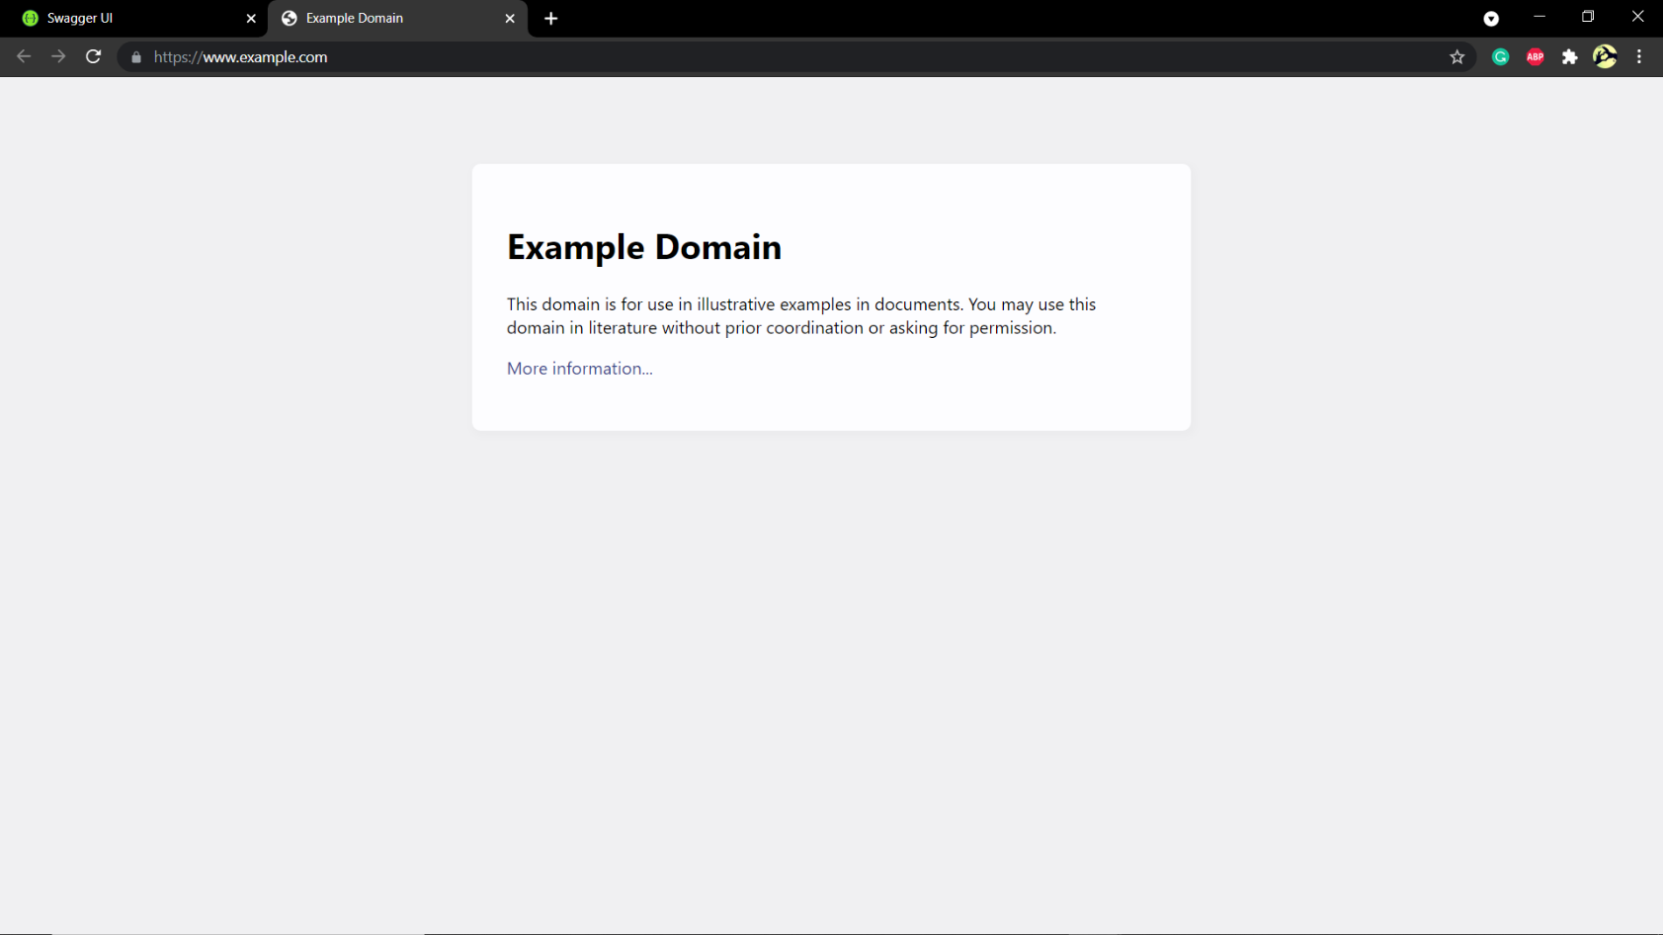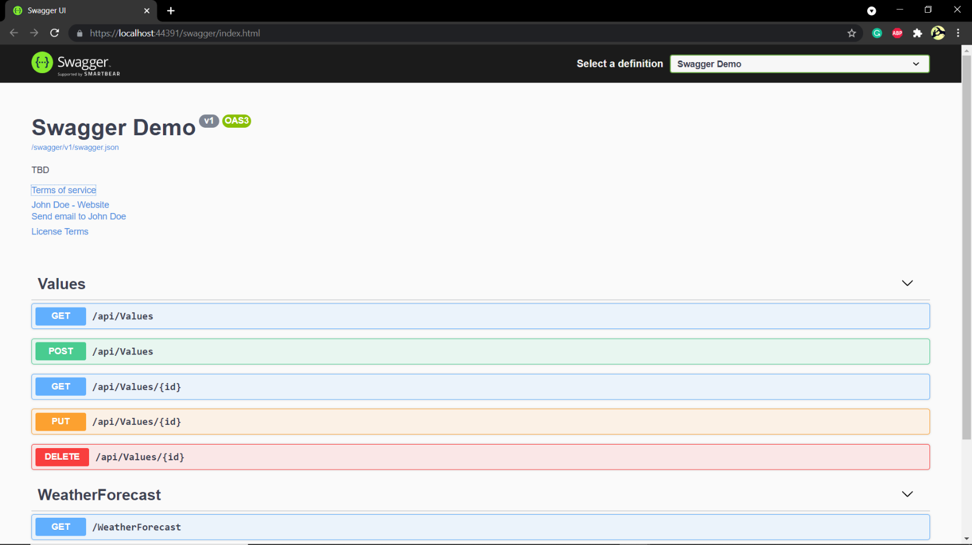**OUTPUT:**

1. **Web Api using custom model class**

**Employee.cs**

using System;

using System.Collections.Generic;

using System.Linq;

using System.Threading.Tasks;

namespace ThirdWebAPI.Models

{

    public class Employee

    {

        public int Id { get; set; }

        public string Name { get; set; }

        public int Salary { get; set; }

        public bool Permanent { get; set; }

        public string Department { get; set; }

        public string Skills { get; set; }

        public DateTime DateOfBirth { get; set; }

    }

}

**EmployeesController.cs**

using Microsoft.AspNetCore.Mvc;

using Microsoft.AspNetCore.Http;

using Microsoft.AspNetCore.Authorization;

using System;

using System.Collections.Generic;

using System.Linq;

using System.Threading.Tasks;

using ThirdWebAPI.Models;

using ThirdWebAPI.Filters;

// For more information on enabling Web API for empty projects, visit https://go.microsoft.com/fwlink/?LinkID=397860

namespace ThirdWebAPI.Controllers

{

    [Route("api/[controller]")]

    [ApiController]

    public class EmployeesController : ControllerBase

    {

        private Employee[] emp = new Employee[]

       {

        new Employee { Id=1 , Name="ankit" , Salary=20000 , Permanent=true, Department="CS",Skills="Dotnet" ,DateOfBirth=new DateTime(1998,08,07) },

        new Employee { Id=2 , Name="Ashu" , Salary=15000 , Permanent=true, Department="Electronics",Skills="java" ,DateOfBirth=new DateTime(1999,11,09) } ,

        new Employee { Id=3 , Name="Shivam" , Salary=10000 , Permanent=false, Department="Mech",Skills="php" ,DateOfBirth=new DateTime(1997,02,12) } ,

       };

        private IEnumerable<Employee> GetStandardEmployeeList()

        {

            return emp;

        }

        // GET: api/<ValuesController1>

        [CustomAuthFilter]

        [HttpGet]

        public IEnumerable<Employee> Get()

        {

            return GetStandardEmployeeList();

        }

        // GET api/<ValuesController1>/5

        [HttpGet("{id}")]

        [ProducesResponseType(StatusCodes.Status200OK)]

        [ProducesResponseType(StatusCodes.Status404NotFound)]

        public IActionResult GetById(int id)

        {

            var prod = emp.FirstOrDefault((p) => p.Id == id);

            if (prod == null)

            {

                return NotFound();

            }

            return Ok(prod);

        }

        // POST api/<ValuesController1>

        [HttpPost]

        public void Post([FromBody] string value)

        {

        }

        // PUT api/<ValuesController1>/5

        [HttpPut("{id}")]

        public void Put(int id, [FromBody] string value)

        {

        }

        // DELETE api/<ValuesController1>/5

        [HttpDelete("{id}")]

        public void Delete(int id)

        {

        }

    }

}

**CustomAuthFilter.cs**

using Microsoft.AspNetCore.Mvc;

using Microsoft.AspNetCore.Mvc.Filters;

using Microsoft.Extensions.Primitives;

using System;

using System.Collections.Generic;

using System.Diagnostics;

using System.Linq;

using System.Threading.Tasks;

namespace ThirdWebAPI.Filters

{

    public class CustomAuthFilter : ActionFilterAttribute

    {

        public override void OnActionExecuting(ActionExecutingContext context)

        {

            if (context.HttpContext.Request.Query.ContainsKey("Authorization") && context.HttpContext.Request.Query["Authorization"] == "true")

            {

                context.Result = new UnauthorizedResult();

            }

            else

            {

                base.OnActionExecuting(context);

            }

        }

    }

}

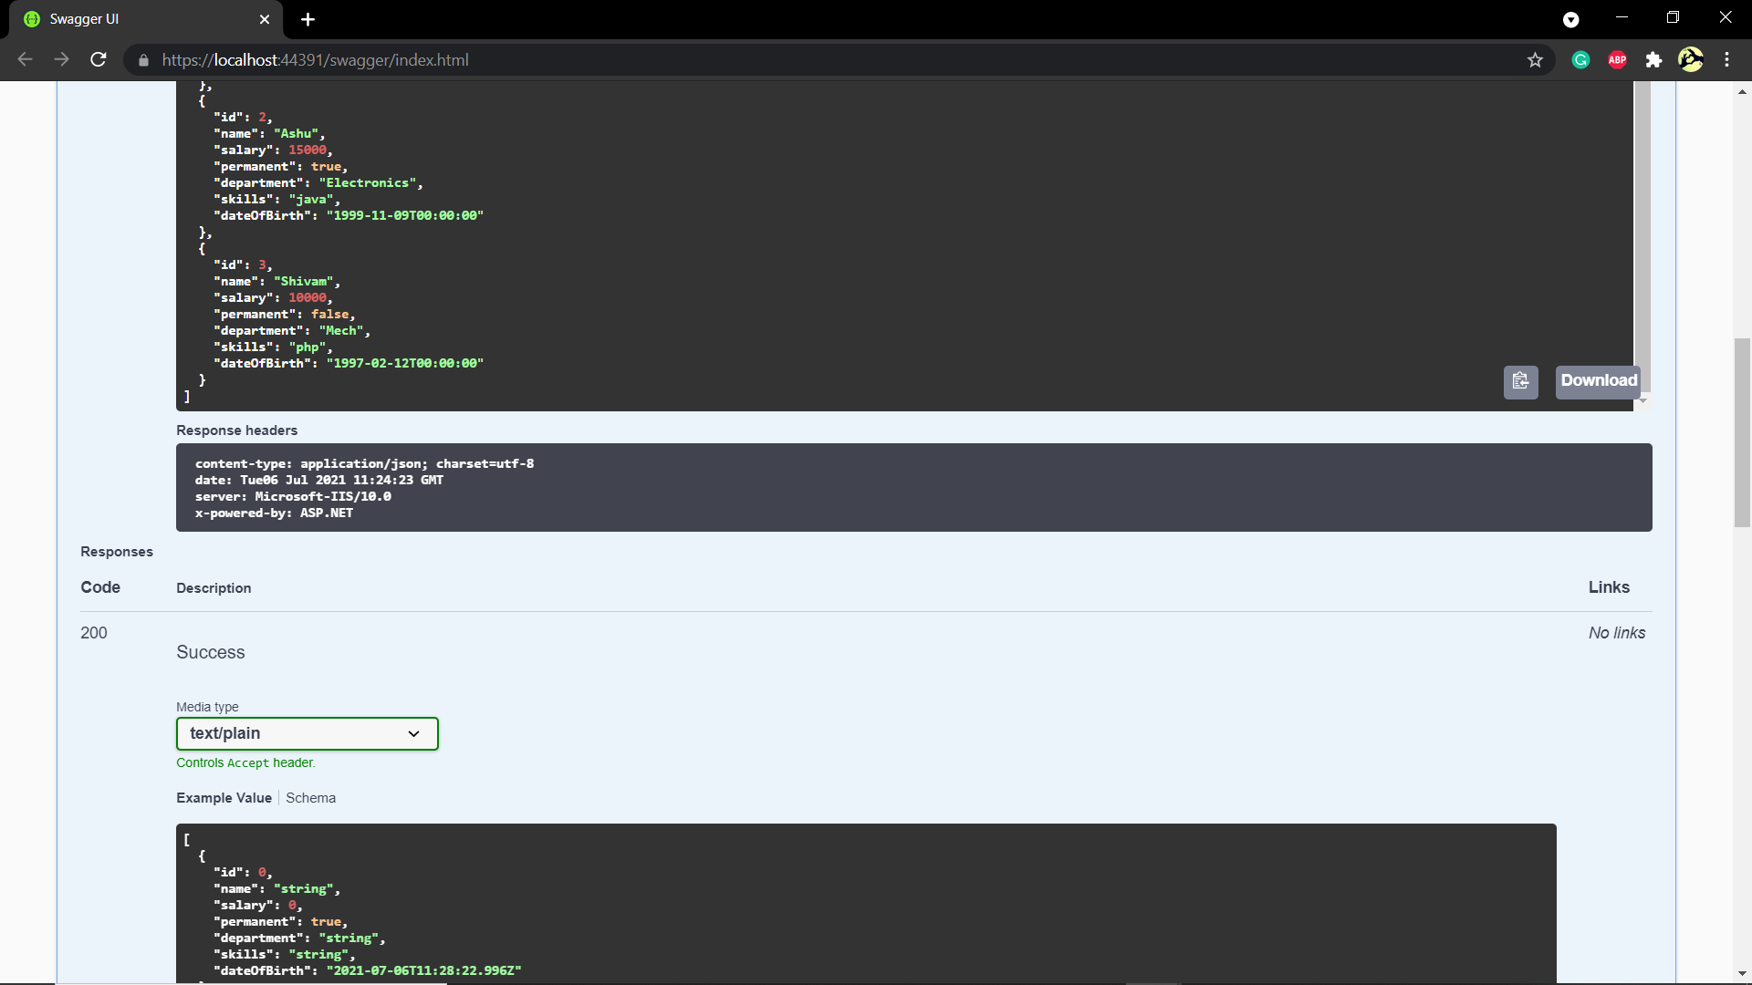**OUTPUT:**

1. **Web Api CRUD operation**

**Employee.cs**

using System;

using System.Collections.Generic;

using System.Linq;

using System.Threading.Tasks;

namespace ThirdWebAPI.Models

{

    public class Employee

    {

        public int Id { get; set; }

        public string Name { get; set; }

    }

}

**EmployeesController.cs**

using Microsoft.AspNetCore.Mvc;

using Microsoft.AspNetCore.Http;

using Microsoft.AspNetCore.Authorization;

using System;

using System.Collections.Generic;

using System.Linq;

using System.Threading.Tasks;

using ThirdWebAPI.Models;

using ThirdWebAPI.Filters;

// For more information on enabling Web API for empty projects, visit https://go.microsoft.com/fwlink/?LinkID=397860

namespace ThirdWebAPI.Controllers

{

    [Route("api/[controller]")]

    [ApiController]

    public class EmployeesController : ControllerBase

    {

        private static List<Employee> _emp = new List<Employee>();

        // GET: api/<ValuesController1>

        [HttpGet(Name = "GetAllStudent")]

        public IActionResult Get()

        {

            return new ObjectResult(_emp);

        }

        // GET api/<ValuesController1>/5

        [HttpGet("{id}", Name = "GetStudent")]

        public IActionResult Get(int id)

        {

            return new ObjectResult(_emp.FirstOrDefault(p => p.Id == id));

        }

        // POST api/<ValuesController1>

        [HttpPost(Name = "CreateStudent")]

        public IActionResult Post([FromBody] Employee emps)

        {

            _emp.Add(emps);

            return CreatedAtRoute("GetStudent", new { id = emps.Id }, emps);

        }

        // PUT api/<ValuesController1>/5

        [HttpPut("{id}", Name = "UpdateStudent")]

        public IActionResult Put(int id, [FromBody] Employee emps)

        {

            _emp.FirstOrDefault(p => p.Id == id).Name = emps.Name;

            return CreatedAtRoute("GetStudent", new { id = emps.Id }, emps);

        }

        // DELETE api/<ValuesController1>/5

        [HttpDelete("{id}", Name = "DeleteStudent")]

        public IActionResult Delete(int id)

        {

            var _emps = _emp.FirstOrDefault(p => p.Id == id);

            _emp.Remove(_emps);

            return new NoContentResult();

        }

    }

}

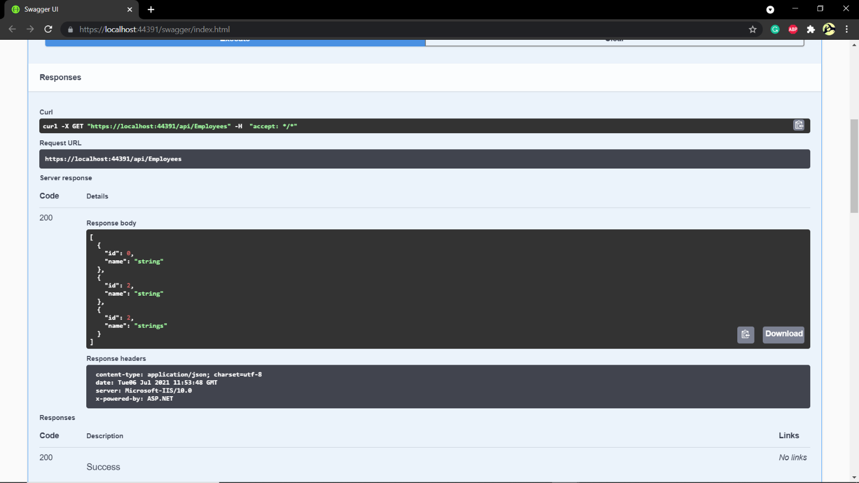**OUTPUT:**

